**GIT HANDSON**

Exercise – 5

**Clean up and push back to remote Git**

1. Clean Up Your Local Repository

* First, you need to remove any unwanted files and folders from your project.
* To remove a file that is already tracked by Git, use the git rm <filename> command.
* To remove untracked files that Git doesn't know about, use the git clean -f command.
* To remove both untracked files and untracked folders, use the git clean -fd command.
* To check if there are any changes left, use the git status command.

2. Commit Your Cleaned Changes

* Next,need to save the cleanup actions to your repository's history.
* To stage all your changes (like the file removals), use the git add . command.
* To commit the staged changes with a descriptive message, use the git commit -m "Your message" command.

3. Push Back to Remote

* Finally, update the remote repository with the cleaned version of your branch.
* To push your local commits to the remote repository, use the git push origin <branch-name> command.

Step1: Check main status is clean

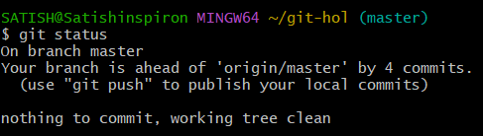

Step2: Add git remote origin using hhtps of repository

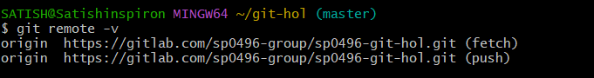

Step3: Pull the remote git repository to the master

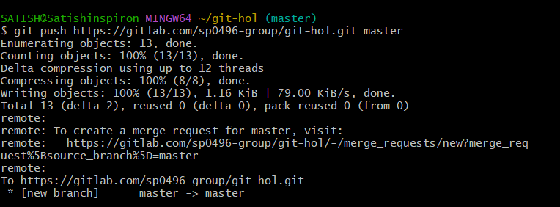

Step4: Changes are reflected in the remote repository

